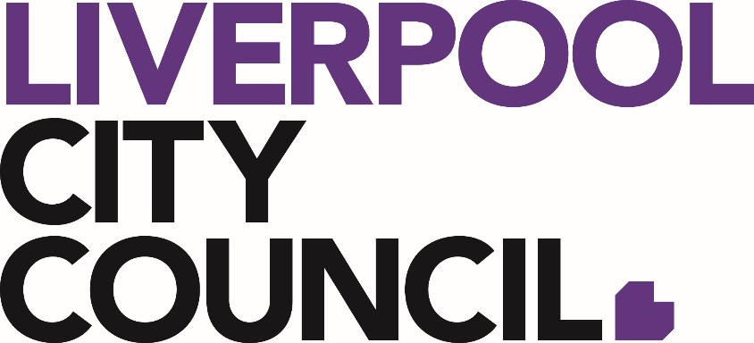

Liverpool City Council
Environment Advisory Committee (EAC)

Nomination Information

Community Member

For a copy of the Environment Advisory Committee (EAC) Charter is available on Councils Website with the Nomination Forms.

Liverpool City Council
Environment Advisory Committee (EAC)

Liverpool City Council is seeking expressions of interest from members of the public with an interest in the natural environment and catchment management of the Liverpool LGA to be appointed by Council to the Liverpool Environment Advisory Committee. Committee members serve in a voluntary capacity.

This committee has been established primarily to consider and provide input to Council’s environment programs by making recommendations to Council.The functions of the Environment Advisory Committee are to:

- Consider key environmental issues facing Liverpool and make recommendations to Council;
- Consider key floodplain and stormwater management issues facing Liverpool and make recommendations to Council;
- Consider sustainability and waste management issues facing Liverpool and make recommendations to Council;
- Provide input to the development and implementation of Council’s community education and engagement programs relevant to environment, sustainability, waste and water management;
- Provide input into the planning and implementation of the Environment Restoration Plan program, and other such Council programs relevant to environment, sustainability, waste and water management; and
- Work in partnership with Council in terms of various environmental and floodplain management initiatives, providing opportunities for meaningful community participation.

Membership Assessment Criteria

Your application for membership as a community member to the Environment Advisory Committee will be assessed against the following criteria.

- Demonstrated interest in conserving, maintaining and protecting the natural environment;
- Demonstrated experience/knowledge in environmental, floodplain and waste management issues;
- Ability to achieve objectives in a team environment;
- Willingness to participate in community capacity building to achieve broad environmental, floodplain and waste management outcomes; and
- Commitment to represent the interest of the community in environment, water and floodplain management issues.

Membership Term

As outlined in the Environment Advisory Committee Charter, and in accordance with Council’s Resolution of 24 September 2014, the term of membership is typically two years.

Successful applicants will be invited to sit on the current Environment Advisory Committee membership term from April 2021 until December 2022.

Proposed 2021 meeting dates:

- Monday, 12 April
- Tuesday, 15 June
- Monday, 9 August
- Monday, 11 October
- Monday, 13 December

Liverpool City Council
Environment Advisory Committee (EAC)
Nomination Form – Community Membership

Name

Organisation/Business
Contact Number |  | (Office)
 |  | (Mobile)

Email

Please tell us how you meet the criteria for membership as set out in the constitution.

- Demonstrated interest in conserving, maintaining and protecting the natural environment
__________________________________________________________________________________________________________________________________________________________________________________________________________________________________________________________________________________________________________________________________________________________________

- Demonstrated experience/knowledge in environmental, floodplain and waste management issues.

_____________________________________________________________________________________________________________________________________________________________________________________________________________________________________________________________________________________________________________________________________________________________________________________________________________________________

- Ability to achieve objectives in a team environment

__________________________________________________________________________________________________________________________________________________________________________________________________________________________________________________________________________________________________________________________________________________________________

- Willingness to participate in community capacity building to achieve broad environmental, floodplain and waste management outcomes

__________________________________________________________________________________________________________________________________________________________________________________________________________________________________________________________________________________________________________________________________________________________________

- Commitment to represent the interest of the community in environment, water and floodplain management issues.

__________________________________________________________________________________________________________________________________________________________________________________________________________________________________________________________________________________________________________________________________________________________________

Also please tell us:

Are you a member of any active community environmental group within Liverpool?

yes no

If yes, please specify
____________________________________________________________________________________________________________________________________________________________________________________________________________________________________________

Are you a member of any other Environmental or social cause group?

yes no

If yes, please specify
____________________________________________________________________________________________________________________________________________________________________________________________________________________________________________

Optional – Please tell us about your other affiliations, interests and hobbies.
____________________________________________________________________________________________________________________________________________________________________________________________________________________________________________

Please tick if you would like more information on Council’s Environmental Programs.

This form is to be completed and sent back to Council by
5pm, Wednesday 20 January 2020

Please send to:

Alexi Gilchrist
Coordinator Environment Restoration Plan
City Infrastructure and Environment
Liverpool City Council

By Email:
gilchrista@liverpool.nsw.gov.au

By Fax:
(02) 9821 9333

By Mail:
Locked Bag 7064
LIVERPOOL BC NSW 1871

In Person:
Ground Floor
33 Moore Street, Liverpool

