Liverpool City Council is exhibiting a planning proposal request which seeks to amend the Key Sites Map in the Liverpool Local Environmental Plan 2008 (Map Amendment No. 4). Council invites members of the public to view the proposal and provide feedback.
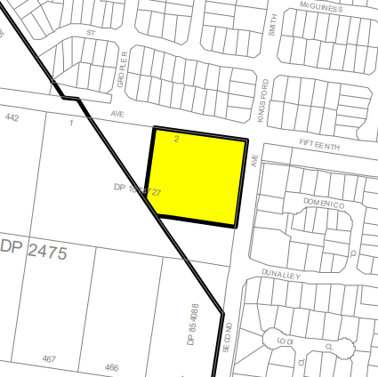

What is the Liverpool Local Environmental Plan?
The Liverpool Local Environmental Plan 2008 (LLEP 2008) contains zoning and planning controls to guide future development. Some of the controls include the types of development permitted on a particular site, including floor space and height to which a development can be constructed.

What changes are proposed?
The planning proposal seeks to amend the Key Sites Map in the LLEP 2008 to relocate the existing yellow key site shape that applies to 104 Fifteenth Avenue, West Hoxton (Lot 2 DP 1074727). The key site provision allows for the development of a service station and take away food and drinks premises at the site as additional permitted uses.
Although the planning proposal only relates to the location of the key site shape, the proposal is intended to facilitate the development outcome proposed under DA-750/2021, which is also on public exhibition. Details regarding this application can be found on the DA-750/2021 fact sheet.

How can I make a submission?
Written submissions are to be addressed to the CEO and can be made via:
- NSW Planning Portal;
- Council’s Website; or
- lcc@liverpool.nsw.gov.au
Submissions are to be received by 5pm 7 August 2022, quoting RZ-5/2021.

Where can I get more information?
Please direct enquires about the planning proposal to Lilyan Abosh, Strategic Planner on 8711 7631 or aboshl@liverpool.nsw.gov.au.

What happens next?
Public submissions for Map Amendment No. 4 will be considered and reported to a future Council meeting.

